**Weapons**

When designing the weapons, we opted for an approach in which we would generate the weapon damage colliders during animations of the attacks. This would be done through the Unreal's notifies system.

**Notifies:**

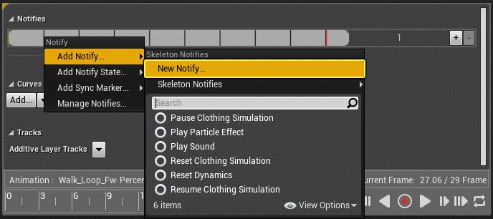

Notifies are animation events used to call functions during a specific frame of an animation’s runtime. With that said there use for player and enemy attacks is extremely useful when calling functions to generate the damage colliders on given frames of specific animations:

**Damage Colliders:**

In the function above we would create a new actor with a spherical collider attached, in which any enemy hit by it would take an instance of damage dictated by the ‘damage’ parameter and knocked back with the direction and distance based off the ‘direction’ parameter.

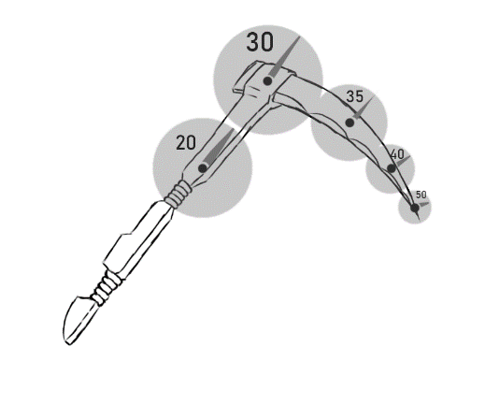

*Figure - Scythe with damage colliders visible (not final values)*

The position these spherical colliders will spawn will be based on the ‘position’ parameter. These will be weapon anchors, empty classes with a transform component attached, each will be attached as a sub object of the weapon they are used for. This is so that any change in direction and position the weapon has will also then be mirrored onto these anchors.

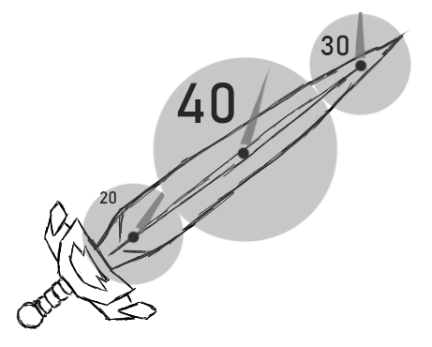

*Figure - Sword with damage colliders visible (not final values)*